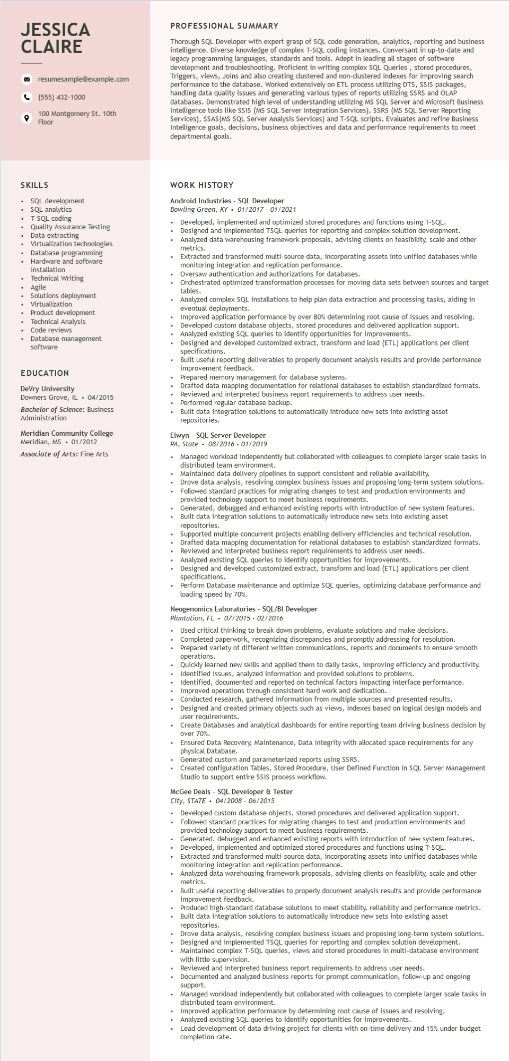
JESSICA CLAIRE
resumesample@example.com
(555) 432-1000
100 Montgomery St. 10th Floor
PROFESSIONAL SUMMARY
Thorough SQL Developer with expert grasp of SQL code generation, analytics, reporting and business intelligence. Diverse knowledge of complex T-SQL coding instances. Conversant in up-to-date and legacy programming languages, standards and tools. Adept in leading all stages of software development and troubleshooting. Proficient in writing complex SQL Queries, stored procedures, Triggers, views, Joins and also creating clustered and non-clustered indexes for improving search performance to to the database. Worked extensively on ETL process utilizing DTS, SSIS packages, handling quality issues and generating various types of reports utilizing SSRS and OLAP databases. Demonstrated high level of understanding utilizing MS SQL Server and Microsoft Business Intelligence tools like SSIS (MS SQL Server Integration Services), SSRS (MS SQL Server Reporting Services), SSAS (MS SQL Server Analysis Services) and T-SQL scripts. Evaluates and refine Business Intelligence goals, decisions, business objectives and data and performance requirements to meet departmental goals.
data
SKILLS
SQL development
• SQL analytics
T-SQL coding
Quality Assurance Testing Data extracting Virtualization technologies Database programming Hardware and software installation
Technical Writing
• Agile
Solutions deployment Virtualization Product development Technical Analysis Code reviews
Database management software
EDUCATION
DeVry University
Downers Grove, IL. 04/2015
Bachelor of Science: Business Administration
Meridian Community College Meridian, MS. 01/2012 Associate of Arts: Fine Arts
WORK HISTORY
Android Industries - SQL Developer
Bowling Green, KY 01/2017 - 01/2021
Developed, implemented and optimized stored procedures and functions using T-SQL. Designed and implemented TSQL queries for reporting and complex solution development. Analyzed data warehousing framework proposals, advising clients on feasibility, scale and other metrics.
• Extracted and transformed multi-source data, incorporating assets into unified databases while monitoring integration and replication performance.
Oversaw authentication and authorizations for databases.
Orchestrated optimized transformation processes for moving data sets between sources and target tables.
• Analyzed complex SQL installations to help plan data extraction and processing tasks, aiding in eventual deployments.
Improved application performance by over 80% determining root cause of issues and resolving. Developed custom database objects, stored procedures and delivered application support. Analyzed existing SQL queries to identify opportunities for improvements.
Designed and developed customized extract, transform and load (ETL) applications per client specifications.
Built useful reporting deliverables to properly document analysis results and provide performance improvement feedback.
Prepared memory management for database systems.
Drafted data mapping documentation for relational databases to establish standardized formats. Reviewed and interpreted business report requirements to address user needs.
Performed regular database backup.
Built data integration solutions to automatically introduce new sets into existing asset repositories.
Elwyn SQL Server Developer
PA, State 08/2016 - 01/2019
.
•
Managed workload independently but collaborated with colleagues to complete larger scale tasks in distributed team environment.
Maintained data delivery pipelines to support consistent and reliable availability.
Drove data analysis, resolving complex business issues and proposing long-term system solutions. Followed standard practices for migrating changes to test and production environments and provided technology support to meet business requirements.
Generated, debugged and enhanced existing reports with introduction of new system features. Built data integration solutions to automatically introduce new sets into existing asset repositories.
Supported multiple concurrent projects enabling delivery efficiencies and technical resolution. Drafted data mapping documentation for relational databases to establish standardized formats. Reviewed and interpreted business report requirements to address user needs. Analyzed existing SQL queries to identify opportunities for improvements.
Designed and developed customized extract, transform and load (ETL) applications per client specifications.
Perform Database maintenance and optimize SQL queries, optimizing database performance and loading speed by 70%.
Neogenomics Laboratories - SQL/BI Developer
Plantation, FL
07/2015-02/2016
Used critical thinking to break down problems, evaluate solutions and make decisions. Completed paperwork, recognizing discrepancies and promptly addressing for resolution.
Prepared variety of different written communications, reports and documents to ensure smooth operations.
Quickly learned new skills and applied them to daily tasks, improving efficiency and productivity. Identified issues, analyzed information and provided solutions to problems.
Identified, documented and reported on technical factors impacting interface performance. Improved operations through consistent hard work and dedication.
Conducted research, gathered information from multiple sources and presented results.
Designed and created primary objects such as views, indexes based on logical design models and user requirements.
Create Databases and analytical dashboards for entire reporting team driving business decision by over 70%.
Ensured Data Recovery, Maintenance, Data Integrity with allocated space requirements for any physical Database.
Generated custom and parameterized reports using SSRS.
Created configuration Tables, Stored Procedure, User Defined Function in SQL Server Management Studio to support entire SSIS process workflow.
McGee Deals - SQL Developer & Tester
City, STATE 04/2008 - 06/2015
Developed custom database objects, stored procedures and delivered application support. Followed standard practices for migrating changes to test and production environments and provided technology support to meet business requirements.
Generated, debugged and enhanced existing reports with introduction of new system features. Developed, implemented and optimized stored procedures and functions using T-SQL.
Extracted and transformed multi-source data, incorporating assets into unified databases while monitoring integration and replication performance.
Analyzed data warehousing framework proposals, advising clients on feasibility, scale and other metrics.
Built useful reporting deliverables to properly document analysis results and provide performance improvement feedback.
Produced high-standard database solutions to meet stability, reliability and performance metrics. Built data integration solutions to automatically introduce new sets into existing asset
repositories.
Drove data analysis, resolving complex business issues and proposing long-term system solutions. Designed and implemented TSQL queries for reporting and complex solution development. Maintained complex T-SQL queries, views and stored procedures in multi-database environment with little supervision.
Reviewed and interpreted business report requirements to address user needs.
Documented and analyzed business reports for prompt communication, follow-up and ongoing Suppor support.
Managed workload independently but collaborated with colleagues to complete larger scale tasks in distributed team environment.
Improved application performance by determining root cause of issues and resolving.
Analyzed existing SQL queries to identify opportunities for improvements.
Lead development of data driving project for clients with on-time delivery and 15% under budget completion rate.

